**ECE 09495/09595**

**Quiz # 1 Jacob Matteo**

**Instructions**

1. Allowed Time: 2 weeks.
2. Maximum points – 100.
3. Submit a single PDF or MS Word file. Please do not provide your code.
4. Answer all questions.

**All files are on my github under Assignments/Quizzes/Quiz1:** [**https://github.com/jmatteo/Machine-Learning-Fall-20**](https://github.com/jmatteo/Machine-Learning-Fall-20)

**Question 1 (10 points)**

The CIFAR-10 dataset (<https://www.cs.toronto.edu/~kriz/cifar.html> ) consists of 60000 32x32 color images in 10 classes, with 6000 images per class. There are 50000 training images and 10000 test images. We will train a CNN for the classification. We have a working model (***Q1.py***) and the validation accuracy of this model is around 79.70%.

1. **Task**: Please use **data augmentation** and see if you can improve validation accuracy. Please feel free to tune any hyperparameters you like including number of convolution layers, convolution kernel size, max pooling layers, optimizers type, leaning rate, number of epochs, batch size, etc. You may want to explore (<https://keras.io/preprocessing/image/#imagedatagenerator>) for data augmentation.
2. **Result Reporting**: A graph of epochs vs training/validation accuracy for your model that achieved highest validation accuracy. Please do not include your code.

|  |
| --- |
| **BASE: 79 %ish**  **5th model.add 64->128: 80%ish**  **Rest model.add doubled: 82%ish**  **Epochs to 150, 2nd pool size doubled: 83.81%**  **1st pool size doubled: 81.81%**  **1st pool size then quartered: 81.75%**  **Batch size doubled: 82.32%**  **Don’t remember the change: 81.85**  **20 classes: 82.97%**  **40 classes: 81.76%**  **2nd pool size doubled again: 79.59%**  **Added keras tf preprocessing block:82.55%**  **Added keras data augmentation block: crashes google colab- fixed: 80.82%** |
| **Chart  Description automatically generatedplot from matlab with all values copied by hand cause I couldn’t get my plot function to work** |

**Question 2 (10 points)**

We are using the CIFAR-10 dataset and we are using ResNet (***Q2.py***). The model is working and produces reasonable validation accuracy. Please see network architecture (for ResNet20) in the attached figure.

1. **Task**: Please run the model for different depths (20, 32, 44, 56). Please modify the code to remove skip connections and train the model for different depths (20, 32, 44, 56).
2. **Result Reporting**: Please fill the following table:

|  |  |  |  |  |
| --- | --- | --- | --- | --- |
| **Model Depth** | **With skip connection** | | **Without skip connection** | |
| Training accuracy | Validation accuracy | Training accuracy | Validation accuracy |
| 20 | 1.000 | .8005 | .4326 | .4313 |
| 32 | 1.000 | .8140 | .4346 | .4303 |
| 44 | 1.000 | .8215 | .4345 | .4326 |
| 56 | 1.000 | .8202 | .4321 | .4308 |

**Question 3 (10 points)**

We are using the same CIFAR-10 data with an Inception module (Q3.py) this time. The network consists of a single inception module and does not seem to perform well (training accuracy > 99.9% , and validation accuracy $≈60\%$).

1. **Task**: Please modify the network to improve its validation accuracy.
2. **Result Reporting**: Please include your code and report the maximum validation accuracy.

|  |
| --- |
| **Base: 0.5834**  **200 epochs: 0.5579**  **Vol1 conv2D 64->96: 57.62%**  **Vol3 conv2D doubled: 57.98%**  **V4 MacPool2d doubled: 57.05%**  **^^ ¼’d: 57.06%**  **2 more volume lines: 57.87%**  **1 more volume line, fed off another volume line: 58.89%**  **2 more like above: 61.57%**  **Oops forgot to concatenate the new volumes: 65.6%**  **3 more volumes: 68.23% See code below:** |
| '''  Q3 Inception Module for CIFAR-10 dataset  '''  import keras  from keras.models import Model  from keras.layers import Conv2D, MaxPooling2D  from keras.layers import Flatten, Dense  from keras.layers import Input  from keras.utils import np_utils  from keras.datasets import cifar10  epochs = 100  # Get the data  (X_train, y_train), (X_test, y_test) = cifar10.load_data()  # Get the data ready  X_train = X_train.astype('float32')  X_test = X_test.astype('float32')  X_train = X_train / 255.0  X_test = X_test / 255.0  y_train = np_utils.to_categorical(y_train)  y_test = np_utils.to_categorical(y_test)  # Create input  input_img = Input(shape = (32, 32, 3))  # Create Volumes for the Inception module  volume_1 = Conv2D(96, (1,1), padding='same', activation='relu')(input_img)  volume_2 = Conv2D(96, (1,1), padding='same', activation='relu')(input_img)  volume_2 = Conv2D(128, (3,3), padding='same', activation='relu')(volume_2)  volume_3 = Conv2D(32, (1,1), padding='same', activation='relu')(input_img)  volume_3 = Conv2D(64, (5,5), padding='same', activation='relu')(volume_3)  volume_4 = MaxPooling2D((2,2), strides=(1,1), padding='same')(input_img)  volume_4 = Conv2D(32, (1,1), padding='same', activation='relu')(volume_4)  volume_5 = Conv2D(128, (2,2), padding='same', activation='relu')(input_img)  volume_5 = Conv2D(256, (5,5), padding='same', activation='relu')(volume_5)  volume_6 = Conv2D(32, (1,1), padding='same', activation='relu')(input_img)  volume_6 = Conv2D(64, (10,10), padding='same', activation='relu')(volume_6)  volume_7 = MaxPooling2D((2,2), strides=(1,1), padding='same')(volume_3)  volume_7 = Conv2D(32, (4,4), padding='same', activation='relu')(volume_7)  volume_8 = MaxPooling2D((2,2), strides=(1,1), padding='same')(volume_1)  volume_8 = Conv2D(32, (4,4), padding='same', activation='relu')(volume_8)  volume_9 = MaxPooling2D((2,2), strides=(1,1), padding='same')(volume_5)  volume_9 = Conv2D(32, (4,4), padding='same', activation='relu')(volume_9)  volume_10 = MaxPooling2D((2,2), strides=(1,1), padding='same')(volume_5)  volume_10 = Conv2D(32, (4,4), padding='same', activation='relu')(volume_10)  volume_11 = MaxPooling2D((2,2), strides=(1,1), padding='same')(volume_10)  volume_11 = Conv2D(32, (4,4), padding='same', activation='relu')(volume_11)  volume_12 = MaxPooling2D((2,2), strides=(1,1), padding='same')(volume_7)  volume_12 = Conv2D(32, (4,4), padding='same', activation='relu')(volume_12)  # Concatenate all volumes of the Inception module  inception_module = keras.layers.concatenate([volume_1, volume_2, volume_3,                                               volume_4, volume_5, volume_6,                                               volume_7, volume_8, volume_9,                                               volume_10, volume_11, volume_12], axis = 3)  output = Flatten()(inception_module)  out    = Dense(10, activation='softmax')(output)  model = Model(inputs = input_img, outputs = out)  print(model.summary())  model.compile(loss='categorical_crossentropy', optimizer='adam', metrics=['accuracy'])  hist = model.fit(X_train, y_train, validation_data=(X_test, y_test), epochs=epochs, batch_size=512)  scores = model.evaluate(X_test, y_test, verbose=0)  print("Accuracy: %.2f%%" % (scores[1]*100)) |

**Questions 4-6 (30 points)**

We will train a character level LSTM on a small text, few paragraphs from Chapter 1 of Bertrand Russell’s book “Conquest of Happiness”.

1. **Task**: Train the model (***Q4_Train.py***) for various input size, i.e., the number of character given to the LSTM for making a prediction about the next character (try 5/10/20/30/40/50). Test your model using Q4_Test.py for each trained model and generate 10/50/100/500 characters for each model.
2. **Result Reporting**: Looking at the generated text, please comment on:
3. **What is the effect of number of characters given to the LSTM during training?**
   1. *As the number of characters inputted increases, the higher the accuracy of the network is. This results in lower losses at the cost of speed. This is because of the large amounts of data the training algorithm needs to process in order to complete each epoch.*
4. **What is the effect of number of characters generated by the LSTM during testing?**
   1. *Changing the number of characters to be generated creates much larger outputs, but ends up being less accurate as the more letters which need to be created, the less accurate it gets.*
5. **Report perplexity curve for the best model.**

Perplexity vs epochs for different lengths (k)

**Questions 7-8 (20 points)**

We want to extend the same LSTM network for a big dataset (A Tale of Two Cities, a novel by Charles Dickens). The model is available ***Q5_Train.py***.

1. **Task**: Please make appropriate choices for the:
2. Number of LSTMs : 1
3. Size of each LSTM : 512
4. Dropout : 0.1
5. Number of epochs: 10
6. The batch size : 1024
7. **Result Reporting**:
   1. Please provide a paragraph of almost 500 characters generated by your trained LSTM.
8. nd the searen of the searen of the searen of the searen of the searen of the searen of the searen of the searen of the searen of the searen of the searen of the searen of the searen of the searen of the searen of the searen of the searen of the searen of the searen of the searen of the searen of the searen of the searen of the searen of the searen of the searen of the searen of the searen of the searen of the searen of the searen of the searen of the searen of the searen of the searen of the sea
   * 1. yeah this was poor performance
   1. Report model perplexity curve for the best model.

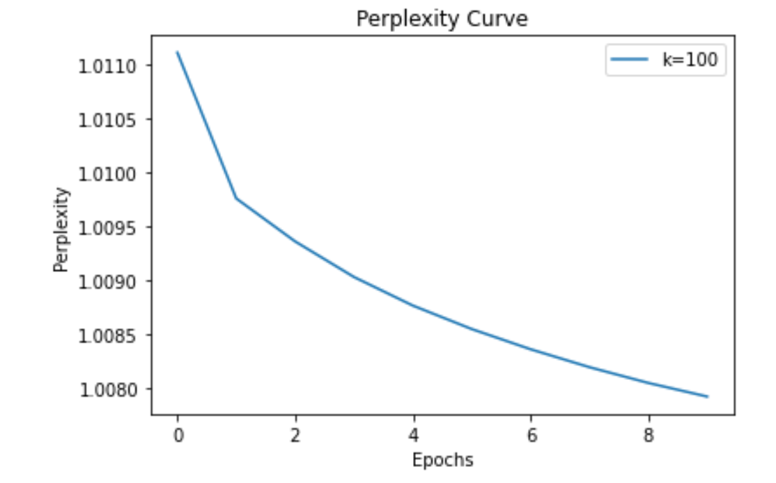

**Questions 9-10 (20 points)**

1. **Task**: Extend the character level LSTM to word level GRU for the same input (A Tale of Two Cities, a novel by Charles Dickens).
2. **Result Reporting**:
   1. Please provide a paragraph of almost 100 words generated by your trained model.
3. of in that tone of yours charles darnay it is a tone of fervent admiration true homage and deep love doctor manette he said deferentially there was another blank silence before her father rejoined i believe it i do you justice i believe it his constraint was so manifest and it was so manifest too that it originated in an unwillingness to approach the subject that charles darnay hesitated shall i go on sir another blank yes go on you anticipate what i would say though you cannot know how earnestly i say it how earnestly i feel it without knowing my secret heart and the hopes and fears and anxieties with which it has long been laden dear doctor manette i love your daughter fondly dearly disinterestedly devotedly if ever there were love in the world i love her you have loved yourself let your old love speak for me the doctor sat with his face turned away and his eyes bent on the ground at the last words he stretched out his hand again hurriedly and cried not that sir let that be i adjure you do not recall that his cry was so like a cry of actual pain that it rang in charles darnays ears long after he had ceased he motioned with the hand he had extended and it seemed to be an appeal to darnay to pause the latter so received it and remained silent i ask your pardon said the doctor in a subdued tone after some moments i do not doubt your loving lucie you may be satisfied of it he turned towards him in his chair but did not look at him or raise his eyes his chin dropped upon his hand and his white hair overshadowed his face have you spoken to lucie no nor written never it would be ungenerous to affect not to know that your selfdenial is to be referred to your consideration for her father her father thanks you he offered his hand but his eyes did not go with it i know said darnay respectfully how can i fail to know doctor manette i who have seen you together from day to day that between you and miss manette there is an affection so unusual so touching so belonging to the circumstances in which it has been nurtured that it can have few parallels even in the tenderness between a father and child i know doctor manette how can i fail to know that mingled with the affection and duty of a daughter who has become a woman there is in her heart towards you all the love and reliance of infancy itself i know that as in her childhood she had no parent so she is now devoted to you with all the constancy and fervour of her present years and character united to the trustfulness and attachment of the early days in which you were lost to her i know perfectly well that if
   1. Report model perplexity curve for the best model.

